THE GOSPEL FAITH MISSION INTERNATIONAL, NORTH AMERICA
NATIONAL “FIVEFOLD MINISTRY’ PRAYER CAMPAIGN.
PASTOR.
Ebenezer Ikenebomeh
Text: When he [Jesus] ascended up on high, he led captivity captive, and gave gifts unto men……And he gave some, APOSTLES; and some, PROPHETS; and some, EVANGELISTS; and some, PASTORS and TEACHERS. — Ephesians 4:8,11.
“Churches evolve, and one of the duties of an apostolic leader in the tribe of Issachar is to know exactly where the work is, what the Lord is saying, and what should be the next point of action according to the divine blueprint. Without an iota of doubt, I am persuaded that the full exploration of the fivefold ministry to bring about a permanent revolution for bumper harvests should be our next point of action that would propel us to the next level of grace in GOFAMINT NA.”
—Pastor Sunday Adu (Convention 2021)

Introduction
The ministry gifts, as they are often called, are the callings and various abilities given to certain believers by Jesus Christ that enable them to stand in the offices of apostle, prophet, evangelist, pastor or teacher. No one can put himself or herself into one of these offices. Rather, one must be called and gifted by God.

Special Note:

- They are not titles, they are functions. Let the function speak for themselves. They cannot be demanded, but honored by the fruit of their ministry.
- The number five is symbolic of God’s grace, goodness and favor towards humanity. We have been given five fingers on each hand and five toes on each foot. We have five senses.
- The Fivefold is the five senses of the church Body. They are all designed to sense heaven within these five ministry gifts because they are essential for the growth of the Body.
- 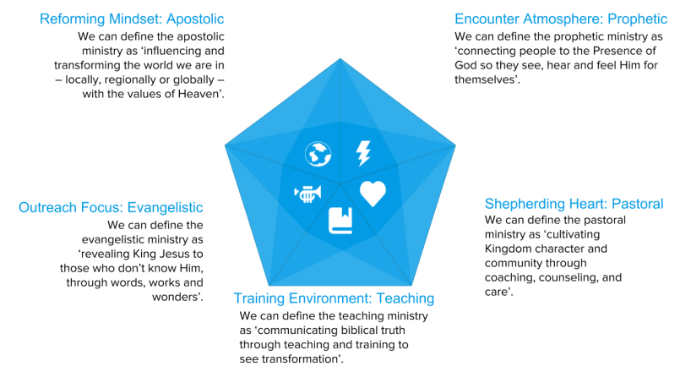
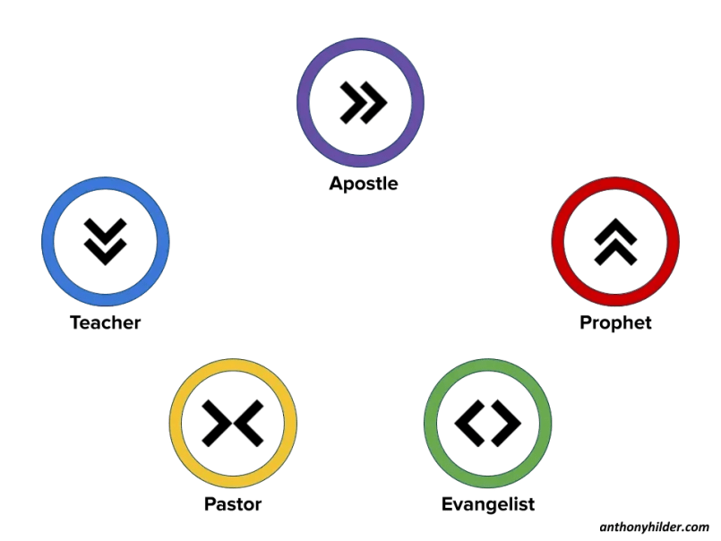

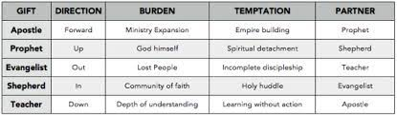

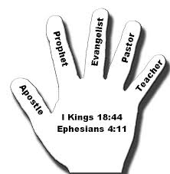
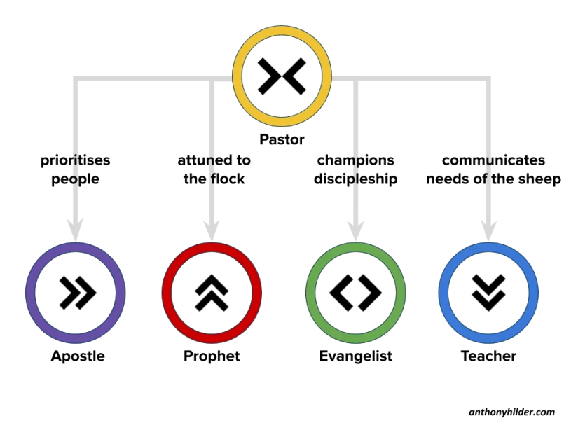
- A pastor partners with an apostle by reminding them that not only are their people in the mission, but prioritising people because they ARE the mission.
- A pastor partners with prophets by helping keep them attuned to the flock and peoples sensitivities, helping the church grasp and lean into the prophetic promises and revelation so they can practically access them.
- A pastor partners with evangelists by championing discipleship, reminding them that discipleship is the goal of evangelism and not just conversion.
- A pastor partners with teachers by communicating the needs of the sheep, connecting them to the needs of the people and helping them apply scripture to their lives.
Without a healthy pastoral influence that brings compassion and love to move people forward in spiritual maturity, the church becomes inward-looking, needs-focused and takes its eyes off mission. People will not mature and grow the way they are intended to.

The office of the Pastor
Pastors are represented on the hand by the ring finger which speaks of covenant relationship.
As shepherds of the Lord's flock, pastors have a covenant relationship and obligation to the flock.
Pastor comes from the Greek word poimen, meaning “a herdsman or shepherd.” Just as a shepherd cares for the sheep in his flock, ensuring that they are fed, healthy and safe from potential predators, so is a pastor to guard the souls within his/her care.

Office of the Pastor in the Old Testament:
Numbers 27:15-17 Then Moses spoke to the LORD, saying: “Let the LORD, the God of the spirits of all flesh, set a man over the congregation, who may go out before them and go in before them, who may lead them out and bring them in, that the congregation of the LORD may not be like sheep which have no shepherd.”
- God is a shepherd to His people, but God’s people also need a human representative of the Lord to exercise a shepherding care and concern for them.
- Without shepherds, sheep will not be able to take care of themselves

And I will give you pastors according to mine heart, which shall feed you with knowledge and understanding. Jeremiah 3:15

Jesus the Pastor
“I am the good shepherd. The good shepherd gives His life for the sheep. ¹² But a hireling, he who is not the shepherd, one who does not own the sheep, sees the wolf coming and leaves the sheep and flees; and the wolf catches the sheep and scatters them. ¹³ The hireling flees because he is a hireling and does not care about the sheep. ¹⁴ I am the good shepherd; and I know My sheep, and am known by My own. Jn.10:11-14 (NKJV).
A TRUE SHEPHERD | A HIRELING
1. Has a personal interest in the general well-being of the sheep (Pro. 27:23). | 1. Neglects the sheep (Ezek. 34:4).
2. Leads the sheep (Ps. 80:1). | 2. A hireling drives the sheep for his own personal gain (Ezek. 34:4).
3. Causes the sheep to lie down and rest (Ezek. 43:11). | 3. Rules with cruelty and force (Ezek. 34:4).
4. Brings back those sheep driven away (Ezek. 34:16). | 4. Fails to bring back those sheep driven away (Ezek. 34:4).
5. Knows the sheep (Ezek. 34:11-12). | 5. Is ignorant of his Sheep (Jer. 23:1).
6. Binds up the broken sheep (Ezek. 34:4). | 6. Abuses the sheep (Jer. 23:1).
7. Protects the sheep (Ezek. 34:4). | 7. Leaves when the wolf comes (John 10:12).
8. Gives his life for the sheep (John 10:11). | 8. Takes the life of the sheep for himself (Ezek. 34:3).
9. Feeds the sheep from good pastures (Ps. 23:2). | 9. Feeds self, not the flock (Ezek. 34:1).
10. Watches the flock by night (Luke 2:8). | 10. Is idle and leaves the flock (Zech. 11:17).
11. Restores the soul of sheep (Ps. 23:3). | 11. Cares not for the sheep (John 10:13).
12. Seeks the lost sheep (Ezek. 34:16). | 12. Fails to seek the lost sheep (Ezek. 34:4).
13. Enters the sheep-fold by the door (John 10:14). | 13. Looks for his own way (Is. 56:11).
14. Gives water to thirsty sheep (Ps. 23:2).  15. Unites with other shepherds to protect each other's flocks (Is. 31:4). | 14. Is filled with strong drink (Is. 56:11).  15. Cares only for his own flock and is harsh and divisive to other flocks (Ex. 2:17).

Fivefold ministers with the gift of pastoring are under-shepherds, as observed in John 10:11-14
The Calling of A Pastor /Shepherd
First of all, every person who is in the church legitimately is called by Jesus.
When Paul wrote to the church at Rome he referred to them as the called of Jesus Christ. (Romans 1:6)
All true believers are called by God. (Romans 8:28)
This call is based on God’s sovereignty.
1. No one volunteers for a particular ministry (John 15:16). You did not choose Me, but I chose you and appointed you that you should go and bear fruit, and that your fruit should remain, that whatever you ask the Father in My name He may give you.
2. God ordains the ministry that we will have (I Cor. 12:18; Eph. 2:8-10; Col. 1:23, 25; I Tim. 1:12).
But now God has set the members, each one of them, in the body just as He pleased. I Corinthians 12:18
And I thank Christ Jesus our Lord who has enabled me, because He counted me faithful, putting me into the ministry… I Timothy 1:12
3. God supplies the grace needed for that ministry (Rom. 12:3; I Pet. 4:10). For I say, through the grace given to me, to everyone who is among you, not to think of himself more highly than he ought to think, but to think soberly, as God has dealt to each one a measure of faith. Romans 12:3 As each one has received a gift, minister it to one another, as good stewards of the manifold grace of God. I Peter 4:10
4. This call is based on God’s need for a channel (Is. 6:8; Rom. 10:14-15).
Also I heard the voice of the Lord, saying: “Whom shall I send, and who will go for Us?” Then I said, “Here am I! Send me.” Isaiah 6:8
How then shall they call on Him in whom they have not believed? And how shall they believe in Him of whom they have not heard? And how shall they hear without a preacher? And how shall they preach unless they are sent? Romans 10:14-15a

The word “call” comes from the Greek word klesis, a forensic term meaning, “to summon to court” with the idea of giving an account.
The word does not emphasize a call to service but a call to accountability (I Cor. 9:16).
For if I preach the gospel, I have nothing to boast of, for necessity is laid upon me; yes, woe is me if I do not preach the gospel!
2. This call can be known (I Tim. 2:7; II Tim. 1:11; Tit. 1:3). …for which I was appointed a preacher and an apostle… I Timothy 2:7a
…to which I was appointed a preacher, an apostle, and a teacher of the Gentiles. II Timothy 1:11
Principle: The specific call of God can only be discovered and realized as one is cooperating with God to fulfill the general call of God.

God uses various ways and means to issue this call.
A. By an audible voice - Joshua (Josh. 1:1), Jeremiah (Jer. 1:4), Jonah (Jonah 1:1)
B. By Vision - Isaiah (Is. 6:1-8), Paul (Acts 9:3-7; 26:13-19)
C. By Dream -Jacob (Gen. 28:12-13), Joseph (Gen. 37:5)
D. By a Theophany (A Visible manifestation to humankind of God) -Abraham (Gen. 2:7), Isaac (Gen. 26:2)
E. By Angelic Visitation - Moses (Ex. 3:2), Gideon (Judges 6:11-22) , Zacharias (Luke 1:11, 19)
F. By Prophecy and the Laying on of Hands - Paul (Acts 9:17; 22:12-16), Timothy (I Tim. 4:14; II Tim. 1:6)
G. By the Inner Conviction and Witness of the Holy Spirit (Eph. 1:18)
God issues His call through reading the Word of God and meditation upon it. As we meditate upon it, we are consciously and unconsciously being identified with the word, just as the food we eat is being assimilated into our very life. Thus, our minds and lives become saturated and identified with the great purpose of God and shaped and molded in accordance with them. It is, therefore, nothing unusual that someone will know himself called to some service and yet not be able to point to a definite experience or definite scripture passage through which God extended the call to the person.
There will always be a confirmation of the call.
A. The Holy Spirit bears witness with our spirit through the peace of God (Col. 3:15). And let the peace of God rule in your hearts, to which also you were called in one body; and be thankful. Someone has once said, “If you can do anything else and have peace of mind, do it!”
B. Leadership over me bears witness (Heb. 13:17).
C. The gifts and graces in my life bear witness (I Tim. 3:2).
D. The people of God bear witness (Acts 6:3).
How does one get into the pastoral ministry?
A. From a personal point of view.
1. Start meeting the needs of the people.
2. Start laying your life down for others.
3. Make yourself a ready volunteer for all kinds of tasks.
4. As you are faithful, God will give you opportunities to touch more.
B. From the local church leadership point of view.
1. Take advantage of the training programs offered by the church.
2. Distinguish yourself as a faithful servant in the house.
3. Get involved with the small group ministry of the church.
4. Share your burden with the leadership team.
5. Co-operate will all of the suggestions that are given to you.
6. Seek the confirmation of the leadership team regarding the call and the timing.
7. Wait for God to open the right door.

Importance of the Pastoral Ministry
All the other ministry gifts would labor in vain without the pastor, because he is the one who is responsible to tend, care for, and nurture the sheep with the Word of God. Sheep will never grow spiritually and never reach full maturity without a shepherd and the local church.
There are two primary organizations or institutions that God has put His approval on. Number one, the home and family which God instituted in Genesis. He instituted that first. Number two, the church which he started in the books of Acts. The local church is like a family; it is a church family. Have you ever noticed that the family and the church are the two units the devil attacks more than anything else?
We need to realize that Jesus Christ, the Head of the Church, is the One who instituted the local church and set the pastoral office in the Body of Christ.
Notice something Jesus said about the pastoral office in Matthew chapter 9.
MATTHEW 9:35–36
35 And Jesus went about all the cities and villages, teaching in their synagogues, and preaching the gospel of the kingdom, and healing every sickness and every disease among the people.
36 But when he saw the multitudes, he was moved with compassion on them, because they fainted, and were scattered abroad, AS SHEEP HAVING NO SHEPHERD.
In the passage above, the Bible didn’t say that when Jesus saw the multitudes, He was moved with compassion because the people fainted as sheep without an apostle or prophet. It didn’t say the multitude fainted as sheep without an evangelist or teacher. No! It says that they fainted and were scattered abroad as sheep without a shepherd! Sheep need a shepherd.
Without True Shepherds | With True Shepherds
Sheep are scattered (Zech. 13:7;Ezek. 34:5-6) | Sheep receive provision (Ps. 23:1-2)
Sheep wander ( Ezek. 34:6) | Sheep receive direction (Num. 27:17; Ps. 80:1)
Sheep are lacking (Jer. 23:4) | Sheep are fruitful (Jer. 23:3)
Sheep are devoured (Ezek. 34:5) | Sheep are kept (Jer. 31:10)
Sheep are weak (Mt. 9:36) | Sheep are strengthened (Ezek. 34:4, 16)

The Responsibility of the Pastor
To the elders among you, I appeal as a fellow elder and a witness of Christ’s sufferings who also will share in the glory to be revealed:
2 Be shepherds of God’s flock that is under your care, watching over them—not because you must, but because you are willing, as God wants you to be; not pursuing dishonest gain, but eager to serve; 3 not lording it over those entrusted to you, but being examples to the flock. 4 And when the Chief Shepherd appears, you will receive the crown of glory that will never fade away.
1 Peter 5:1-4
Peter is an elder and an apostle and he is addressing elders here, but specifically pastors, as shown in verse 2 (the word ‘shepherds’ in the original Greek is the verb form of poimén). In verse 4 he notes the Chief Shepherd, Christ, which shows that pastors are under-shepherds, accountable to the Lord.
Verses 2-3 convey Peter’s six instructions to pastors:“Shepherd God’s flock that is under your care,” which is phrased in the KJV as “Feed the flock of God” (1 Peter 5:2) and this corresponds to what Christ instructed Peter (John 21:15-17).

¹⁵ When they had finished eating, Jesus said to Simon Peter, “Simon son of John, do you love me more than these?”
“Yes, Lord,” he said, “you know that I love you.”
Jesus said, “Feed my lambs.”
¹⁶ Again Jesus said, “Simon son of John, do you love me?”
He answered, “Yes, Lord, you know that I love you.”
Jesus said, “Take care of my sheep.”
¹⁷ The third time he said to him, “Simon son of John, do you love me?” Simon son of John, do you love me? He said, “ Lord, you know all things; you know that I love you.” Jesus said, “ Feed my sheep. Jn.21:15-17 (NIV)
Pastors, if we love Jesus, we must show it by feeding his LAMBS AND SHEEP.
Making sure the believers under their care are spiritually fed is the number one duty of pastors, which includes exposing them to the ministry of other fivefold ministers now & then so that they’ll be “fully equipped for every good work” (Ephesians 4:12).
Feeding believers the word of God is called “the ministry of the word” (Acts 6:1-4). Notice, by the way, that those believers under the pastor’s care are called “God’s flock.”
In other words, believers in the universal Church are God’s sheep, not the pastor’s sheep. The pastor merely shepherds certain believers for the period of time they are under that pastor’s care, which isn’t determined by the pastor, but by the believer (hopefully led of the Holy Spirit).
“When they had finished eating, Jesus said to Simon Peter, “Simon son of John, do you love me more than these?” “Yes, Lord,” he said, “you know that I love you.” Jesus said, “Feed my lambs.” (John 21:15 NIV)
As a shepherd, the pastor is responsible for feeding the flock or congregation. The importance of this task is emphasized by Jesus as he tells Peter three times to feed His sheep. Feeding the congregation means giving them the unadulterated word of God; this is spiritual food for their soul. In the local assembly, the pastor is the primary preacher and teacher (according to the will of God, other five-fold ministerial gifts can have a dual role and serve as a senior pastor of a local assembly).
This will involve ‘weaning’, changing from milk to solid spiritual food, which may be more difficult and challenging, but will bring about greater spiritual growth and reward.
In Hebrews Paul writes: “Anyone who lives on milk, being still an infant, is not acquainted with the teaching about righteousness. But solid food is for the mature, who by constant use have trained themselves to distinguish good from evil.” (Hebrews 5:13-14 NIV).
It is the role of the pastor to feed the flock with spiritual milk or solid food according to their needs and levels of maturity.
Through this, the flock increases in spiritual stature, is enabled to withstand any spiritual attack and live a victorious Christian life.
- Overseeing the flock
Watch over” those believers that are under your care, which means oversee. This means to supervise or manage the believers under the pastor’s care, but it doesn’t mean to tyrannically dominate them in an authoritarian sense. The passage says that pastors are to serve as “overseers” and not lord it over believers, which are “God’s flock.” In light of this, whatever else ‘oversee’ means, we can be sure that it does not mean to lord it over people.
Pastors are overseers of a local assembly, working to guard the flock through exhortations, care, prayer and counsel; and by overseeing the spiritual life of the church as a whole.
Keep watch over yourselves and all the flock of which the Holy Spirit has made you overseers. Be shepherds of the church of God, which he bought with his own blood. I know that after I leave, savage wolves will come in among you and will not spare the flock. Even from among your own number men will arise and distort the truth in order to draw away disciples after them. (Acts 20:28-30 NIV)
The call of a pastor, is to guard and protect the flock. This involves protecting the sheep from wolves and those who may draw them away from God. These metaphorical wolves can come in many forms. It is the duty of the pastor to be on guard against those lurking in the midst of the congregation.
In Scripture, the wolf usually refers to a person who brings an attack on the faith of Christians.
3.Doing the work without dishonest gain
Don’t pursue dishonest gain, which means don’t be greedy. Greed should not be found in pastor’s heart or someone who has been called into the pastoral office

4.Eagerness To Serve
Be eager to serve rather than begrudgingly serve. If a fivefold minister cannot pastor people with gratefulness and enthusiasm he should do something else in God’s service.
5. Not Lording over the flock
Don’t “lord it over” those entrusted to you, which means don’t be a pompous authoritarian. Pastors who lord it over those in their assemblies try to control or subjugate them in the sense of being the ultimate authority (except that they aren’t the ultimate authority, God is). If you’re a pastor or being called into the pastoral office, please don’t do this; serve with a loving, humble servant’s heart. Anyone functioning in the office of pastor who cannot do this needs to find another way to serve the LORD.
6. Being an example to the flock
Be examples to “the flock” in all you say and do. This shows that ministry isn’t just about “the ministry of the Word of God” (Acts 6:1-4), but also actually walking with the Lord and walking in newness of life.
In short, it’s not just talking the talk, it’s walking the walk. Talk is cheap.

When the elders of the church of Ephesus met Paul in Miletus, he instructed them to “Keep watch over yourselves and all the flock of which the Holy Spirit has made you overseers. Be shepherds [pastors] of the church of God, which he bought with his own blood” (Acts 20:28). This shows that elders (presbuteros), overseers (episkopos) and pastors (poimén) are synonymous in the New Testament.
7. Nurturing the flock
Pastors are also called to nurture the flock. While feeding is one aspect of nurturing, the pastor also engages members of the congregation in one on one conversation to care for their individual needs and concerns, or just to stay informed about how they are doing. This is particularly important for those within the body who are weaker or going through a period of test and trial. By tending to people on individual basis, the pastor is able to minister to specific needs more effectively than they would be able to, with just a sermon alone.
The Pastor is called to care for his congregation in issues of everyday life. Nurturing can also include visiting the sick and elderly, and comforting the suffering.
Powerpoint
We can define the pastoral ministry as ‘cultivating Kingdom character and community through coaching, counselling, and care’.
For a shepherd, pastoring involves watching, herding and tending to the sheep.
It means being mindful of their needs and fears, whilst doing what is best for them even if they do not understand it. It is much more than just reacting to expressions of desire.
Biblical pastoring ultimately seeks to empower people to grow in maturity as a disciple of Christ.
More Responsibilities of the Pastor
- Resourcing the church inwards towards one another
- Cultivating a shepherding heart
- Developing compassionate guides
- Promoting spiritual maturing
- Championing family connection
- Guarding the people
- Facilitating wholeness
- Developing communal inclusion

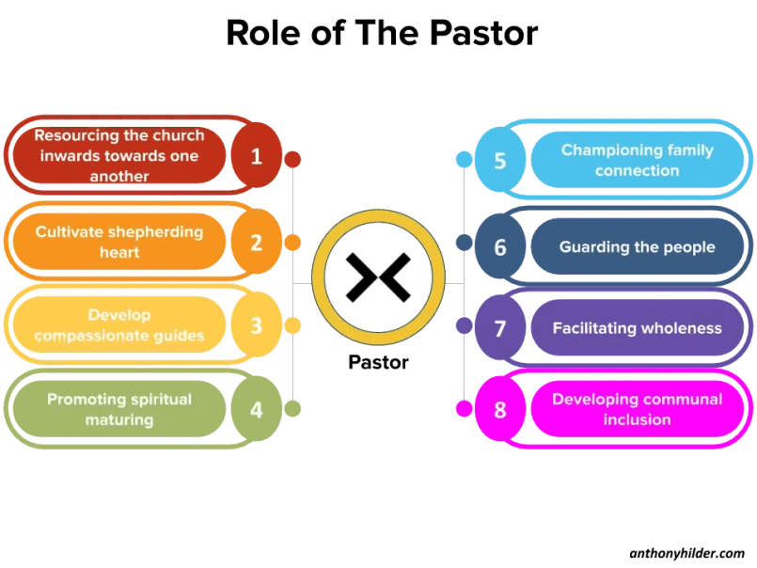

Developing compassionate guides
The first role of the pastor, in line with the mandate of the Ephesians 4 fivefold ministries, is in identifying, developing, and deploying pastoral gifts in others. They will disciple others and help them grow in their ability to love, care for, guide and shepherd others within the church.

Promoting spiritual maturing
As we’ve seen, pastors are shepherds. The role of a pastor is to help facilitate increased Christlikeness and sanctification as a result of a care culture. A healthy church values pastoral care and has a shepherding heart. This leads to the people in the church becoming more mature spiritually, breaking off sin and strongholds, growing in their security and identity, and being able to feed themselves and others. Pastors guide others in their journey of spiritual formation.

Our Statement of Purpose

“To preach the Word of God and to bring people into membership of God’s family; to teach the Word of God to enhance freedom, promote Christian maturity and bind the people to God for service, And to live the word of God to demonstrate the new life in Christ to the World, and ensure the security of the believer”

Championing family connection
As the family of God, believers are meant to live interdependently with one another. The pastor helps connect and maintain loving, godly relationships between people and makes sure that in the busyness of church life and ministry focus, people are not forgotten or overlooked. Reconciling and bringing people together is built around the concept of family, with us all being brothers and sisters, sharing Christ together.

Guarding the people
This has two forms – guarding the people from destructive outsiders (‘wolves) and guarding the people from one another (‘goats’ or misbehaving sheep!)
God’s community is made up of imperfect people who make mistakes, so there are times where the pastor needs to intervene, correct, admonish, rebuke, challenge or even discipline behavior and attitudes that are detrimental to the community as a whole.

Facilitating wholeness
This covers a wide range of things, from the individual – such as prayer for healing, practical care for the sick, counselling, inner healing, and deliverance, to the corporate, such as mediating disputes. The pastor seeks health and wholeness for all, in the physical, emotional and spiritual aspects of being. Biblical wholeness – shalom – is a holistic concept, meaning we have peace in our inner world as well as towards our outer world. This creates the perfect platform for people to discover who they are in God, and what He is calling them to. (Attaining the whole measure of the fullness of Christ. (Eph.4:13)

Developing communal inclusion
The pastor helps champion connections between people, so all are known. Facilitating friendships is key, as is ensuring all are welcome and united. The church should be diverse and include people of all kinds – classes, genders, ethnicities, statuses. There should be openness to all, and favoritism for none. (From him the whole body is joined together by every supporting ligament. Grows and builds itself up in love, as each part does its work (Eph.6:16 NIV)
Challenges of the Pastoral Ministry
Takes on too many people’s problems
Obsessive need for harmony at the expense of truth
Risk averse
- Conflict avoidant
- Lack of a clear plan or strategy
- Lack of time management
- Lack of healthy boundaries
- Measures themselves by ‘counting sheep’
- Driven by approval or disapproval of others
- Co-dependent relationships
Cloying and over-involved in people’s lives

Pitfalls of the Pastoral Ministry
1. Loss of vision
“Be shepherds of God’s flock… not because you must but because you are willing” (5:2).
You set out with vision and passion to serve Christ, but after 5, 10, or 20 years it becomes a job you have to do—another meeting, another sermon, another counseling session. That kind of attitude kills ministry. Peter says, “Don’t get lazy. Make sure your heart is in it.”
2. Desire for gain
“Not greedy for money, but eager to serve” (5:2).
Christ wants you to be eager to serve. You can’t do ministry if you are always asking, “What do I get out of it?” Ministry begins when you start asking, “What can I put into it?”
3. Abuse of power
“Not lording it over those entrusted to you, but being examples to the flock” (5:3).
Lording over others is telling everybody else what to do, when you don’t do it yourself. That’s hypocrisy. The greatest challenge for any Christian leader is to practice what we preach. This is true for a pastor

The Gifts a pastor must possess
A. A pastor or someone with called into the pastoral office should be a man gifted in caring for and loving people. If God has called a man to be a pastor, then surely God has gifted him with a tender heart and an ability to love and be loved by his flock.
We have all known pastors who were adequate in the pulpit, but quite inadequate when it came to connecting in love with their people. Sometimes preachers are virtually unapproachable because they are cold and distant and they have no love for people. But listen to Paul.
“And though I have the gift of prophecy, and understand all mysteries, and all knowledge; and though I have all faith, so that I could remove mountains, and have no charity, I am nothing”. 1 Cor.13:2(NKJV)
What is a pastor if he has all other gifts, but has not love? I’m afraid the answer is, “Nothing.” And so a pastor must be gifted in personal graces and especially in love. Caring and loving the flocks of God are the bedrock of the pastoral ministry.
B. The “called” pastor will have some skill in speaking. Perhaps not an Apollos, who was eloquent beyond his fellows, (Acts 18:24) but nevertheless, a pastor should be of skilled speech in his own way. What is a preacher after all? He is a speaker. He is not primarily a writer of books. He is not an essayist. He is a speaker. And a pastor is a man of words. And therefore, a pastor is a man gifted in speech.
C. A pastor should be a man gifted in biblical and theological knowledge. He should be an educated man, not necessarily educated formally, but educated by some means. The chief duty of the pastor is in communication of the Word of God and this requires certain talents and abilities. It requires an extraordinary ability to think logically and clearly. It requires a facility with language and grammar. And all of this implies a healthy education and a high level of skill in interpreting the Word and in communicating it logically.
John Calvin says for individuals “to glory in a secret call from God, while in the meantime they are unlearned and utterly ignorant” is to demonstrate that they are “fanatics, and actuated by an evil spirit.”
D. The pastor should be a man with a broad general knowledge. A pastor will be a shepherd of men and women from all walks of life. And it will be helpful if he is a widely educated man and a man of general knowledge. He should not be an ignoramus nor a man uninformed. A pastor represents Christ and as much as possible he should be a knowledgeable man in many areas.

Prayers:
- Lord, thank you for putting a program like this in the hearts of our leaders in GOFAMINT NA.
- Thank you, Lord, for raising pastors after your heart in the order of Jesus Christ, our Chief-shepherd. Jn.10:11
Acts 20:28 Keep watch over yourselves and all the flock of which the Holy Spirit has made you overseers. Be shepherds of the church of God, which he bought with his own blood.
3Father, we thank you for the gift of stewardship. We thank you for the flocks that you have given to our pastors to watch over in GOFAMINT NA. Grant them grace to lead as you would.
4. May our Pastor's value of the flock be never diminished in their eyes. May they always remember the price that you paid for every single person under their care.
5. Grant our leaders grace to remain watchful over themselves, that they may not stray from your will, oh Lord!
Hebrews 13:17 Have confidence in your leaders and submit to their authority because they keep watching over you as those who must give an account. Do this so that their work will be a joy, not a burden, for that would be of no benefit to you.
6.Lord, we come against the blinding spirit of pride and arrogance in our church leaders. May they remain coachable.
7.Lord, we pray for GOFAMINT NA. Grant us grace to submit to the authority of the office that our leaders stand under. Give us the wisdom to respect the anointing you have placed on leaders.

8. Lord give our Pastors real heart for the work and love for His people so they can shepherd them with great care and responsibility, knowing that unto the Lord he will give account, in Jesus name.
The God of Israel said, the Rock of Israel spake to me, He that ruleth over men must be just, ruling in the fear of God. (2 Samuel 23:3, KJV)
9. Lord grant all Pastors grace to be patient, stable, and humble to fulfill his ministry, running the race to the end in his efforts to build God's kingdom among people, in Jesus' name. Ask that the Lord will keep him from falling, in Jesus name.
Now unto him, that is able to keep you from falling, and to present you faultless before the presence of his glory with exceeding joy, (Jude 1:24, KJV)

10. Lord touch the hearts of our Chosen Generation to accept the call of God and Grant them the grace to step forward to pursue the call.
11. Lord let there be an explosion of the five-fold ministry gifts in all our assemblies in GOFAMINT NA.
12. Lord strategically position GOFAMINT NA for global harvest in Jesus’ name.

Credits:
  - Fivefold Ministry Training Basic training by I.R Womack
  - He Gave Gifts unto Men by Kenneth E. Hagin
  - Are you harnessing the fivefold-ministry by Anthony Hilder

